SYNOPSIS
The dataset contains 1,000 records of supermarket sales transactions across three branches located in different cities. It provides detailed information about each transaction, capturing multiple variables that reflect customer demographics, purchasing patterns, and financial data.
Key variables include Invoice ID, Branch, and City, which identify where and when the sales occurred. Customer type (Member or Normal) and Gender provide insights into the demographics of shoppers, while Product line categorizes purchases into groups like Health and beauty, Sports and travel, and Home and lifestyle.
Financial attributes such as Unit price, Quantity, Tax 5%, Total, and cogs (cost of goods sold) offer a clear picture of transaction amounts and pricing. The Gross margin percentage and Gross income columns measure profitability on each sale. Additionally, Date and Time provide the precise moment of purchase, which can help in analyzing patterns over time.
The dataset also tracks Payment methods (Cash, Credit card, Ewallet) and Rating, which reflects customer satisfaction on a scale from 1 to 10.
This dataset is ideal for exploring sales trends, customer behaviour, and financial performance. Potential analyses could include evaluating which product lines or cities generate the highest revenue, identifying peak purchasing times, or comparing customer satisfaction across branches. It can also help in understanding the impact of customer types, payment methods, and demographics on sales and profitability. Overall, it provides valuable insights for retail management and strategic decision-making.

INTRODUCTION
The dataset titled "Supermarket Sales" provides a detailed record of transactions from a supermarket, capturing multiple dimensions of each sale. The data consists of 17 columns, each representing key information about the sales. The dataset includes details like the invoice ID, branch, city, customer type (Member or Normal), and customer demographics such as gender. Additionally, it tracks the product line, unit price, quantity sold, tax, total sales amount, date and time of purchase, and payment method (Ewallet, Cash, Credit card).
Sales-related metrics are also incorporated, including the cost of goods sold (COGS), gross margin percentage, and gross income. The dataset even provides customer satisfaction ratings for each transaction, adding an important qualitative aspect.
The dataset spans multiple branches of the supermarket across different cities, namely Yangon, Naypyitaw, and Mandalay, offering insights into geographic sales trends. With product lines such as "Health and Beauty," "Electronic Accessories," "Home and Lifestyle," and "Sports and Travel," the dataset is comprehensive in covering the supermarket’s diverse inventory.
This dataset can be used for various types of analysis, including customer behaviour patterns, sales performance across different product lines, and evaluation of customer satisfaction. It is ideal for exploring sales trends, comparing branch performances, and identifying factors that influence gross income and rating. This dataset is structured and clean, making it suitable for sales forecasting, business intelligence, and customer segmentation studies.

DATA OVERVIEW
The "Supermarket Sales" dataset provides detailed insights into sales transactions across multiple branches of a supermarket chain. It includes essential features such as invoice IDs, customer demographics, product details, and financial metrics, making it suitable for various types of business and data analysis. With 1,000 rows of data, the dataset covers diverse aspects of supermarket operations, including product categories, customer satisfaction ratings, payment methods, and geographic sales distribution across three cities: Yangon, Naypyitaw, and Mandalay. This dataset offers a comprehensive view of the supermarket’s performance, customer behaviour, and sales patterns, making it ideal for analysis in areas such as business intelligence, customer segmentation, and financial forecasting.
COLUMN | DESCRIPTION
Invoice ID | A unique identifier for each transaction or invoice
Branch | The branch of the supermarket where the transaction occurred, with three categories: A, B, and C.
City | The city where each branch is located. It includes three cities: Yangon, Naypyitaw, and Mandalay.
Customer Type | Two types of customers—Member and Normal—indicating whether the customer has a membership with the supermarket.
Gender | The gender of the customer (Male or Female).
Product Line | Categories of products sold in the supermarket,  including:  - Health and Beauty  - Electronic Accessories  - Home and Lifestyle  - Sports and Travel  - Fashion Accessories  - Food and Beverages
Unit Price | The price of a single unit of the product sold, in local currency
Quantity | The number of units of the product purchased in a transaction.
Tax 5% | The amount of tax (5%) applied to the total value of the transaction.
Total | The total transaction value, including tax.
Date | The date when the transaction occurred.
Time | The time of the day the transaction was made.
Payment | The payment method used for the transaction (Ewallet, Cash, or Credit Card).
COGS (Cost of Goods Sold) | The cost of the goods sold in each transaction
Gross Margin Percentage | This field is constant at 4.761905 for all transactions, representing the gross margin percentage.
Gross Income | The gross income derived from the transaction.
Rating | A customer satisfaction rating on a scale from 1 to 10.

DATASET : OPTIMIZING INVENTORY MANAGEMENT ON SUPERMARKET SALES DATA
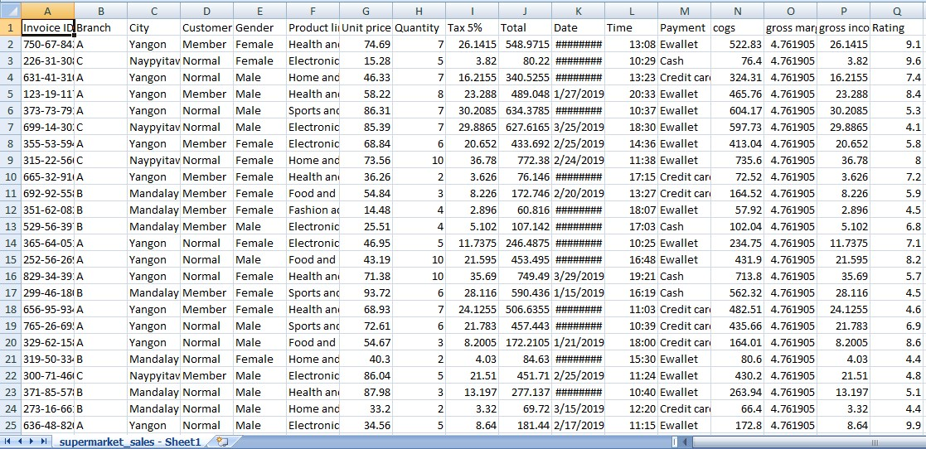

[Figure 1.1]

DATA PREPROCESSING
2 .1 DATA CLEANING
Data cleaning is essential to ensure accurate and reliable analysis. It involves handling missing values, often them with the mean, median, or mode for numeric data, and using methods like forward fill or replacing with the most frequent category for categorical data. Standardizing data types ensures consistency by filling. Removing duplicates is important to prevent skewed results, and outliers are either removed or transformed to avoid distorting the analysis. This process improves data quality and leads to better insights and model accuracy
Coding :
#Import necessary libraries
import pandas as pd
import numpy as np
import matplotlib.pyplot as plt
import seaborn as sns

# Load the dataset
file_path = '/content/supermarket_sales - Sheet1.csv'
df = pd.read_csv(file_path)

# Show basic information about the dataset and the first few rows to understand its structure
df_info = df.info()
df_head = df.head()

df_info, df_head
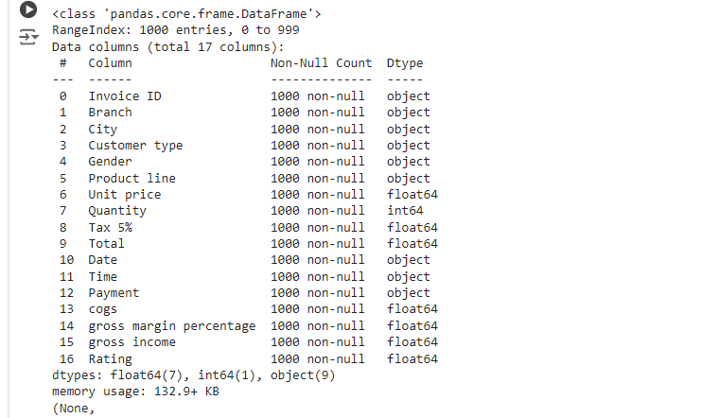

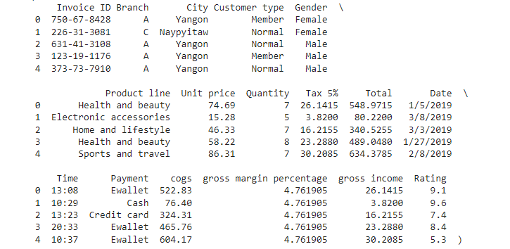

# Drop the 'gross margin percentage' column as it is constant and redundant
if 'gross margin percentage' in df_latest.columns:
df_latest_cleaned = df_latest.drop(columns=['gross margin percentage'])
else:
df_latest_cleaned = df_latest.copy()

# Display the first few rows to confirm the column has been dropped
df_latest_cleaned.head()

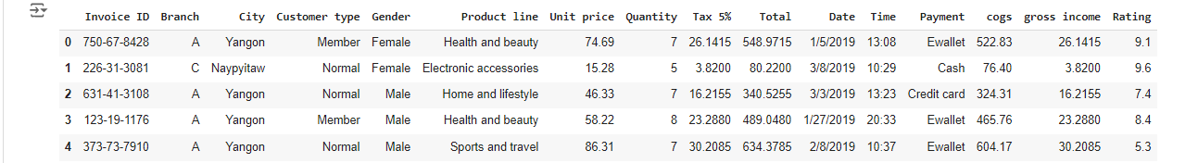
# Checking the missing values
print(df.isnull().sum())

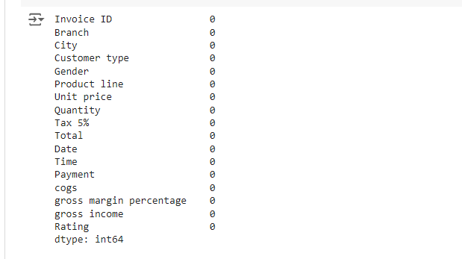
2 .2 DATA CONVERSION
Data conversion is the process of transforming data from one format to another to ensure consistency and usability for analysis. It involves changing the type or structure of the data, such as converting text data into numerical format, or transforming date and time values into standardized forms. This step is crucial to allow efficient processing and ensure that different data points can be compared or analysed correctly. Data conversion also includes adjusting data formats for compatibility with analysis tools, ensuring that all data is interpretable and ready for meaningful insights to be drawn from it.
Coding :
1. Convert columns to appropriate data types
# Convert 'Date' to datetime
df['Date'] = pd.to_datetime(df['Date'], format='%m/%d/%Y')
print(df['Date'])

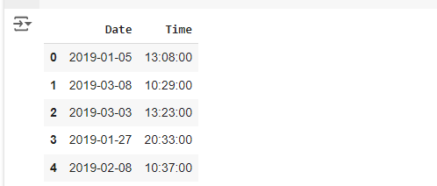
2. Convert categorical columns to category type (if needed)
df['Customer type'] = df['Customer type'].astype('category')
df['Gender'] = df['Gender'].astype('category')
df['Payment'] = df['Payment'].astype('category')
print(df['Customer type'])
print(df['Gender'])
print(df['Payment'])

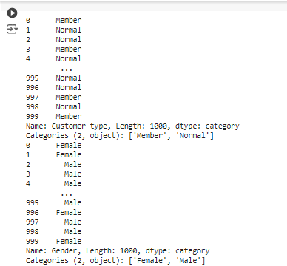

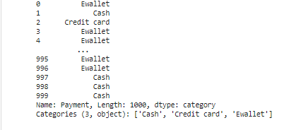

3. Convert numerical columns if necessary
df['Total'] = pd.to_numeric(df['Total'], errors='coerce')
df['Quantity'] = pd.to_numeric(df['Quantity'], errors='coerce')
print(df['Total'])
print(df['Quantity'])

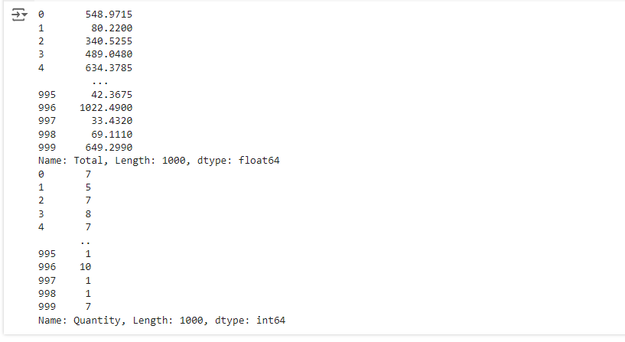

4. Display the updated data types
print(df.dtypes)

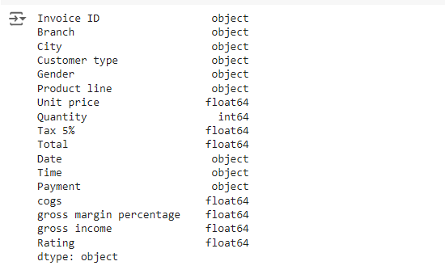

2.3 TEXT DATA PREPROCESSING
Text data preprocessing refers to the techniques used to clean and prepare raw text for analysis, ensuring consistency and eliminating noise. It involves steps like removing special characters, stopwords (common words like "and," "the"), and punctuation. Tokenization splits text into individual words or phrases, while lemmatization or stemming reduces words to their base form. Text normalization converts all text to lowercase to avoid case sensitivity issues. Preprocessing may also include handling missing values, correcting spelling errors, and transforming categorical variables. These steps are crucial for improving the accuracy and efficiency of text-based machine learning models and analytics.
Coding :
# Select columns with text data
text_columns = ['Product line', 'Customer type', 'Payment']
print(df['Product line'])
print(df['Customer type'])
print(df['Payment'])

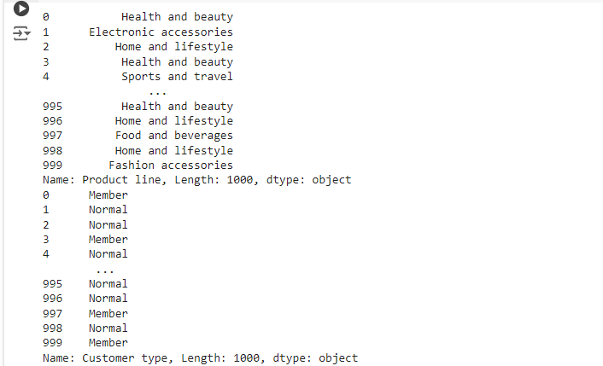
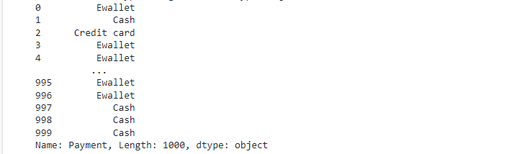

# Define a function for text preprocessing
def preprocess_text(text):
# Convert text to lowercase
text = text.lower()
# Remove punctuation
text = text.translate(str.maketrans('', '', string.punctuation))
# Remove leading/trailing whitespace
text = text.strip()
return text

# Apply text preprocessing to relevant columns
for col in text_columns:
df[col] = df[col].apply(preprocess_text)
print(df[col])

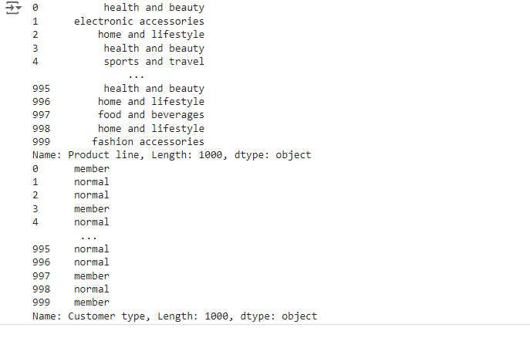
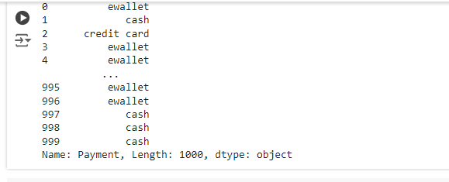
# Display the first few rows to verify preprocessing
print(df[text_columns].head())
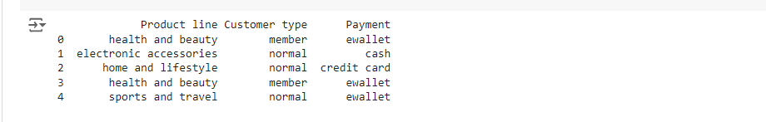

2.4 DATA AGGREGATION
Data Aggregation involves combining multiple data points into a summary, such as calculating the mean, sum, or count over groups. If your dataset has features like average prices or total counts for sellers, this indicates aggregation
Coding :
# Aggregating total sales (sum of 'Total' column) and total quantity sold by both 'City' and 'Branch'
city_sales = df.groupby('City').agg({'Total': 'sum', 'Quantity': 'sum'}).reset_index()
branch_sales = df.groupby('Branch').agg({'Total': 'sum', 'Quantity': 'sum'}).reset_index()

# Display the aggregated results
city_sales, branch_sales

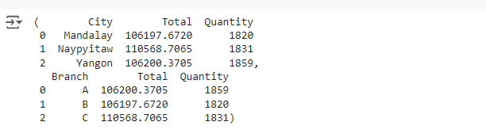

# Aggregating total sales ('Total') and total quantity ('Quantity') based on 'Product line'
product_line_agg = df.groupby('Product line').agg({'Total': 'sum', 'Quantity': 'sum'}).reset_index()

# Display the result
print(product_line_agg)

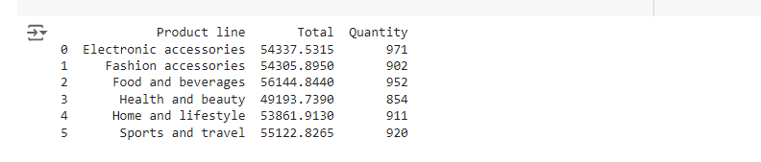

# Summing total sales, taxes, and quantities
total_sales = df['Total'].sum()
total_taxes = df['Tax 5%'].sum()
total_quantity = df['Quantity'].sum()
# Display the results
print(f"Total Sales: {total_sales}")
print(f"Total Taxes: {total_taxes}")
print(f"Total Quantity Sold: {total_quantity}")

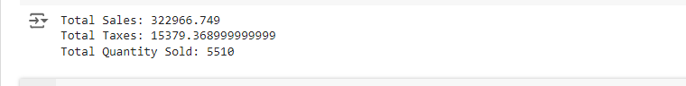

# Grouping by 'Customer type' and aggregating total sales and quantities
customer_type_agg = df.groupby('Customer type').agg({'Total': 'sum', 'Quantity': 'sum'}).reset_index()

# Grouping by 'Payment' method and aggregating total sales and quantities
payment_method_agg = df.groupby('Payment').agg({'Total': 'sum', 'Quantity': 'sum'}).reset_index()

# Display the results
print("Aggregation by Customer Type:")
print(customer_type_agg)
print("\nAggregation by Payment Method:")
print(payment_method_agg)

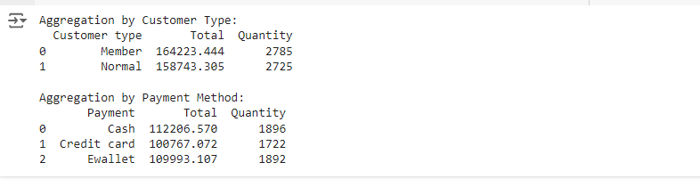

2.5 DATA SPLITTING
This refers to dividing data into subsets, such as training and testing sets for machine learning models or splitting a column into multiple ones. For example, extracting date components from a timestamp.
Coding :

from sklearn.model_selection import train_test_split
import pandas as pd

# Load the dataset (replace 'your_file.csv' with the actual file path)
df = pd.read_csv('/content/supermarket_sales - Sheet1.csv')

# Specify the features (X) and the target variable (y)
# Assuming 'Total' is the target variable, adjust according to your needs
X = df.drop(columns=['Total']) # Features (drop 'Total' as it's the target)
y = df['Total'] # Target variable (Total sales)

# Split the data: 80% for training, 20% for testing
X_train, X_test, y_train, y_test = train_test_split(X, y, test_size=0.2, random_state=42)

# Display the shapes of the resulting datasets
print(f"X_train shape: {X_train.shape}, X_test shape: {X_test.shape}")
print(f"y_train shape: {y_train.shape}, y_test shape: {y_test.shape}"

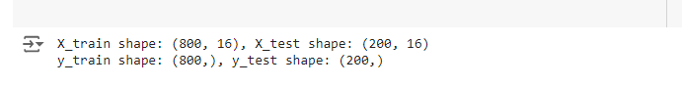

2.6 NORMALIZATION AND SCALING
Normalization is the process of scaling numerical data to a standard range, typically between 0 and 1, or transforming the data to have a mean of 0 and a standard deviation of 1. This helps ensure that all features are on the same scale, which is especially important in machine learning or when comparing metrics with different units. By scaling the data, normalization can enhance the accuracy and generalization of machine learning models. Normalization minimizes the effect of outliers, making the data more robust to extreme values.
Coding :
import pandas as pd
from sklearn.preprocessing import MinMaxScaler, StandardScaler

# Load the dataset (replace 'your_file.csv' with the actual file path)
df = pd.read_csv('/content/supermarket_sales - Sheet1.csv')

# Select numerical columns for scaling (adjust based on your dataset)
# Updated column names to match the names in your CSV
numerical_columns = ['Unit price', 'Quantity', 'Tax 5%', 'Total', 'gross income']

# 1. Min-Max Normalization (scaling values between 0 and 1)
min_max_scaler = MinMaxScaler()
df_min_max_scaled = df.copy()
df_min_max_scaled[numerical_columns] = min_max_scaler.fit_transform(df[numerical_columns])

# 2. Standardization (scaling to mean=0 and std=1)
standard_scaler = StandardScaler()
df_standard_scaled = df.copy() # Changed 'data' to 'df' as 'data' is not defined
df_standard_scaled[numerical_columns] = standard_scaler.fit_transform(df[numerical_columns])

# Display the first few rows of normalized and standardized data
print("Min-Max Normalized Data:")
print(df_min_max_scaled[numerical_columns].head())

print("\nStandardized Data:")
print(df_standard_scaled[numerical_columns].head())

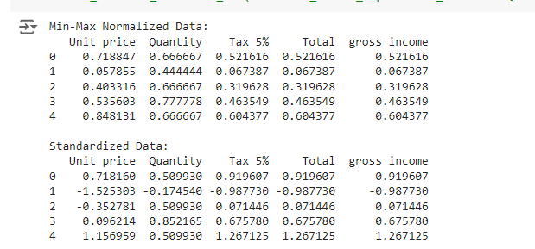

DATA ANALYSIS
3.1 SALES BY CITY AND BRANCH
The Sales by City and Branch analysis provides insights into how revenue is distributed across different supermarket branches in various cities. By grouping the sales data by city and branch, businesses can identify which locations perform better and contribute more to overall revenue. This information is crucial for resource allocation, stock management, and strategic decision-making. Understanding the sales distribution helps businesses focus on high-performing areas while addressing underperforming branches. Additionally, this analysis can help in planning city-specific promotions or improving services in specific branches to increase profitability.
Coding :
import pandas as pd
import seaborn as sns
import matplotlib.pyplot as plt

# Load the dataset (if needed)
# df= pd.read_csv('supermarket_sales - Sheet1.csv')

# Grouping the data by City and Branch, then summing the 'Total' sales
city_branch_sales = df.groupby(['City', 'Branch'])['Total'].sum().reset_index()

# Visualizing the sales by City and Branch
plt.figure(figsize=(10, 6))
sns.barplot(x='City', y='Total', hue='Branch', data=city_branch_sales, palette='Set2')

# Adding labels and title
plt.title('Total Sales by City and Branch', fontsize=16)
plt.xlabel('City', fontsize=12)
plt.ylabel('Total Sales (USD)', fontsize=12)
plt.xticks(rotation=45)
plt.tight_layout()

# Display the plot
plt.show()

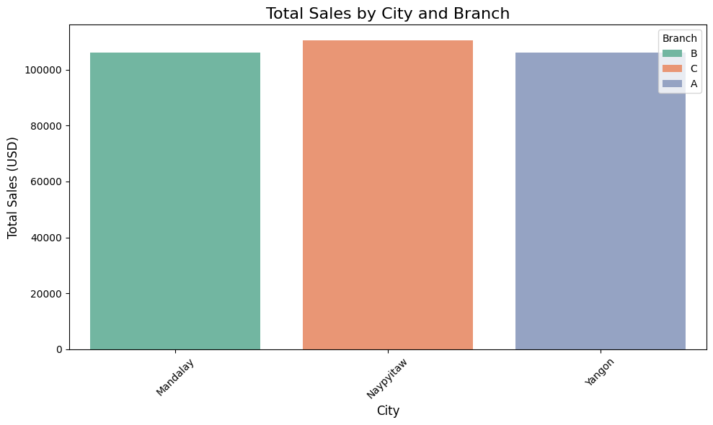
[FIGURE 3.3.1]

3.2 PRODUCT LINE PERFORMANCE
The Product Line Performance analysis evaluates the sales contribution of different product categories within the supermarket. By analyzing sales data across various product lines, businesses can identify which categories are driving the most revenue and which are underperforming. This insight is essential for making informed decisions regarding inventory management, marketing strategies, and promotions. Understanding product line performance helps in focusing efforts on high-demand items, optimizing stock levels, and enhancing profitability. Additionally, this analysis can guide future product expansion or discontinuation of less popular categories, leading to improved overall business efficiency.
Coding :
import pandas as pd
import seaborn as sns
import matplotlib.pyplot as plt

# Load the dataset (if needed)
# df = pd.read_csv('supermarket_sales - Sheet1.csv')

# Grouping the data by 'Product line' and summing the 'Total' sales
product_performance = df.groupby('Product line')['Total'].sum().reset_index()

# Sorting the results by total sales in descending order
product_performance = product_performance.sort_values(by='Total', ascending=False)

# Visualizing the Product Line Performance
plt.figure(figsize=(10, 6))
sns.barplot(x='Total', y='Product line', data=product_performance, palette='coolwarm')

# Adding labels and title
plt.title('Total Sales by Product Line', fontsize=16)
plt.xlabel('Total Sales (USD)', fontsize=12)
plt.ylabel('Product Line', fontsize=12)
plt.tight_layout()

# Display the plot
plt.show()

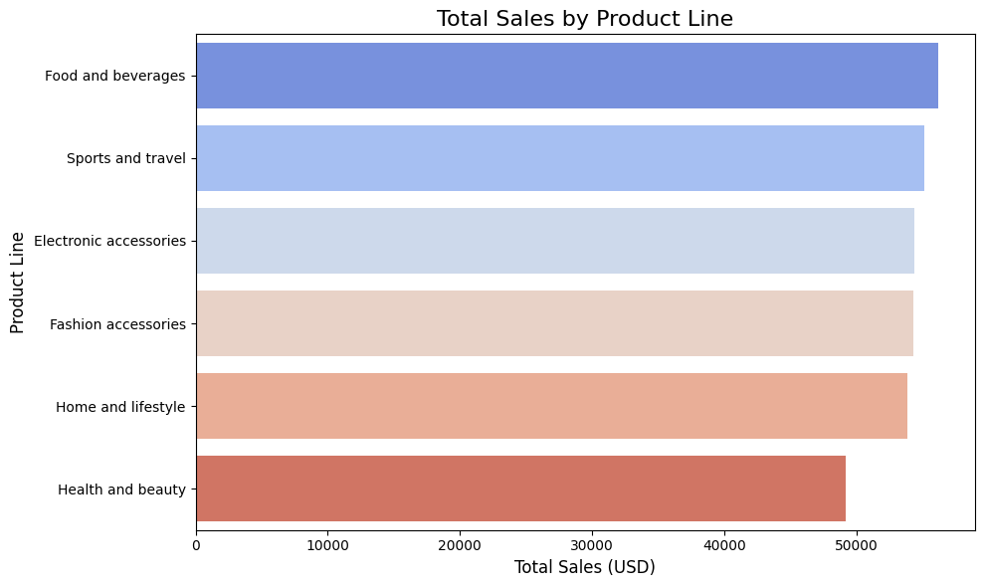
[FIGURE 3.3.2]

3.3 SALES TRENDS OVER TIME
The Sales Trends Over Time analysis tracks the supermarket's revenue patterns across different dates to identify fluctuations and seasonal trends. By evaluating sales data over a specified period, businesses can gain insights into periods of high and low demand. This analysis is crucial for understanding customer purchasing behavior, planning inventory, and optimizing promotional activities. Recognizing consistent patterns allows supermarkets to predict future sales, prepare for peak seasons, and address periods of slow activity. Additionally, understanding these trends can assist in resource allocation, workforce management, and ensuring stock availability during high-demand times, improving overall operational efficiency.
Coding :
import pandas as pd
import seaborn as sns
import matplotlib.pyplot as plt

# Load the dataset (if needed)
# df = pd.read_csv('supermarket_sales - Sheet1.csv')

# Convert the 'Date' column to datetime format
df['Date'] = pd.to_datetime(df['Date'])

# Grouping the data by 'Date' and summing the 'Total' sales
sales_trend = df.groupby('Date')['Total'].sum().reset_index()

# Visualizing the Sales Trends Over Time
plt.figure(figsize=(12, 6))
sns.lineplot(x='Date', y='Total', data=sales_trend, marker='o', color='b')

# Adding labels and title
plt.title('Sales Trends Over Time', fontsize=16)
plt.xlabel('Date', fontsize=12)
plt.ylabel('Total Sales (USD)', fontsize=12)
plt.xticks(rotation=45)
plt.tight_layout()

# Display the plot
plt.show()

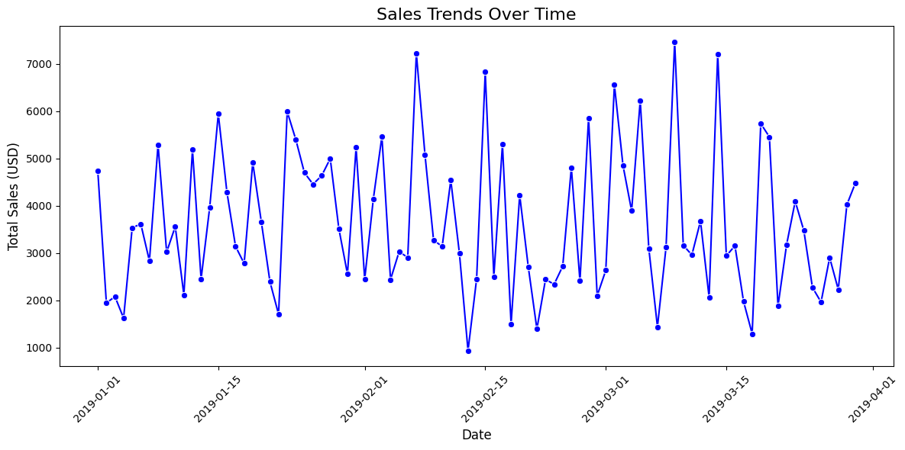
[FIGURE 3.3.3]
3.4 CUSTOMER BEHAVIOUR
The Customer Behaviour analysis examines how various customer demographics, such as gender, payment method, and customer type, influence purchasing patterns. By analyzing these factors, businesses can gain insights into customer preferences, spending habits, and loyalty. For instance, understanding whether certain genders or customer types (e.g., members vs. normal) spend more can help tailor marketing strategies and customer service efforts. Additionally, analyzing payment methods can inform decisions regarding which payment options to promote or optimize. This analysis is essential for improving customer experience, targeting the right audience, and increasing overall customer satisfaction and retention.
Coding :
import pandas as pd
import seaborn as sns
import matplotlib.pyplot as plt

# Load the dataset (if needed)
# df = pd.read_csv('supermarket_sales - Sheet1.csv')

# 1. Sales by Gender
gender_sales = df.groupby('Gender')['Total'].sum().reset_index()

# 2. Sales by Payment Method
payment_sales = df.groupby('Payment')['Total'].sum().reset_index()

# Plotting Sales by Gender
plt.figure(figsize=(10, 5))

# Visualization for Sales by Gender
plt.subplot(1, 2, 1)
sns.barplot(x='Gender', y='Total', data=gender_sales, palette='Set2')
plt.title('Total Sales by Gender')
plt.xlabel('Gender')
plt.ylabel('Total Sales (USD)')

# Visualization for Sales by Payment Method
plt.subplot(1, 2, 2)
sns.barplot(x='Payment', y='Total', data=payment_sales, palette='Set3')
plt.title('Total Sales by Payment Method')
plt.xlabel('Payment Method')
plt.ylabel('Total Sales (USD)')

plt.tight_layout()
plt.show()

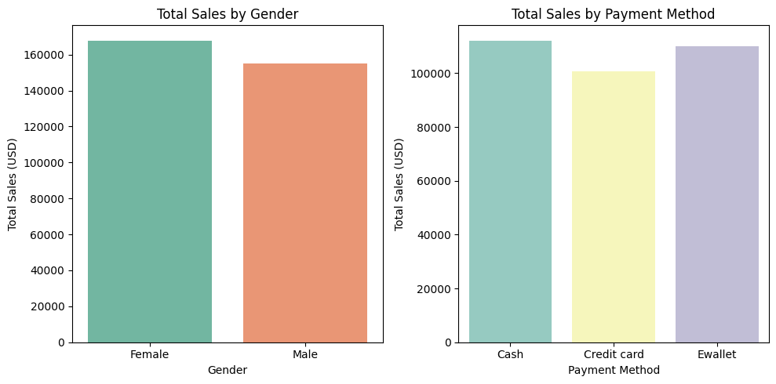
[FIGURE 3.3.4]

DATA VISUALIZATION
4.1 PIE CHART
This code creates a pie chart to visualize the distribution of payment methods (e.g., Cash, Ewallet, Credit card). It uses the plt.pie() function from Matplotlib to show each method’s percentage share in the dataset. The autopct='%1.1f%%' displays percentages on the chart, while the sns.color_palette() function enhances its visual appeal.
Coding :
import pandas as pd
import numpy as np
import matplotlib.pyplot as plt
import seaborn as sns

file_path=('/content/supermarket_sales - Sheet1.csv')
df=pd.read_csv(file_path)

# Calculate the counts of each payment method
payment_method_counts = df['Payment'].value_counts() # This line is added to define 'payment_method_counts'

# Matplotlib's pie chart function can be used to visualize the distribution of payment methods
plt.figure(figsize=(6, 6))
plt.pie(payment_method_counts, labels=payment_method_counts.index, autopct='%1.1f%%', colors=sns.color_palette("Set2"))
plt.title('Distribution of Payment Methods')
plt.tight_layout()

# Display the plot
plt.show()

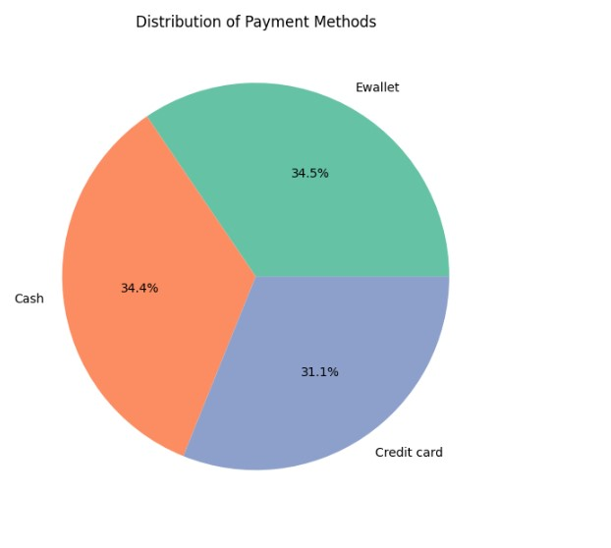
[Figure 4.4.1]
4.2 SCATTER PLOT
This code creates a scatter plot to visualize the relationship between customer ratings and gross income. The sns.scatterplot function is used, with different branches highlighted by color. The plot shows whether higher customer satisfaction ratings tend to correlate with higher gross income.
Coding :
import matplotlib.pyplot as plt
import seaborn as sns

file_path=('/content/supermarket_sales - Sheet1.csv')
df=pd.read_csv(file_path)

# Plotting the correlation between rating and gross income
plt.figure(figsize=(8, 6))
sns.scatterplot(x='Rating', y='gross income', data=df, hue='Branch', palette='coolwarm')

# Adding title and labels
plt.title('Correlation between Rating and Gross Income')
plt.xlabel('Customer Rating')
plt.ylabel('Gross Income')

# Display the plot
plt.tight_layout()
plt.show()

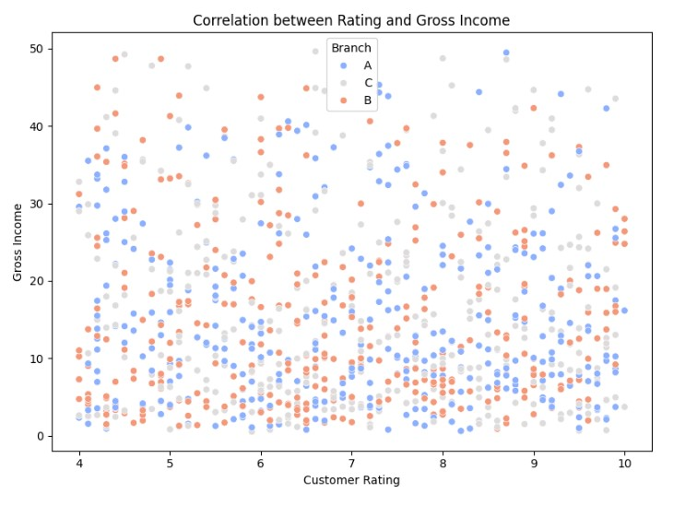
[Figure 4.4.2]
4.3 BAR PLOT
This code groups the data by the "Product line" column and calculates the average customer rating for each product line. The sns.barplot function is then used to create a bar chart, with product lines on the x-axis and their corresponding average ratings on the y-axis. The x-axis labels are rotated for better readability.
Coding :
import matplotlib.pyplot as plt
import seaborn as sns

file_path=('/content/supermarket_sales - Sheet1.csv')
df=pd.read_csv(file_path)

# Grouping the data by Product line and calculating the average rating
avg_rating_by_product_line = df.groupby('Product line')['Rating'].mean().sort_values()

# Plotting the bar chart for average rating by product line
plt.figure(figsize=(10, 6))
sns.barplot(x=avg_rating_by_product_line.index, y=avg_rating_by_product_line.values, palette="Blues_d")

# Adding title and labels
plt.title('Average Customer Rating by Product Line')
plt.xlabel('Product Line')
plt.ylabel('Average Rating')
plt.xticks(rotation=45)

# Display the plot
plt.tight_layout()
plt.show()
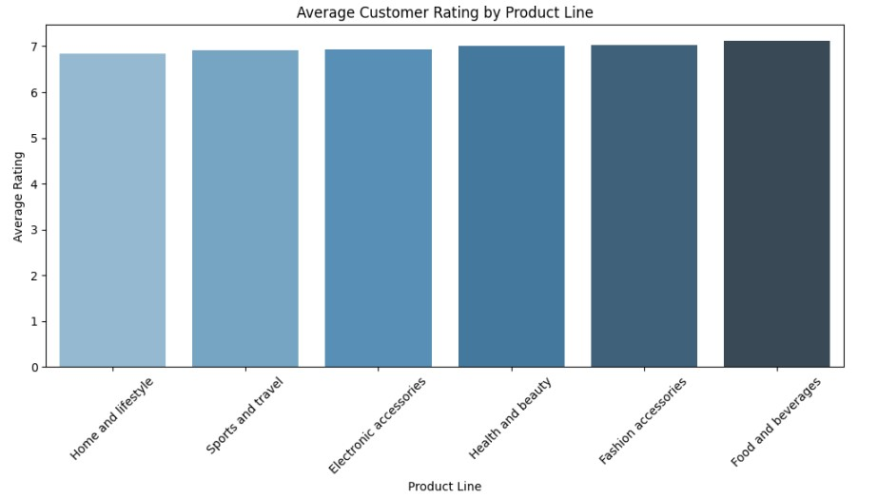

[Figure 4.4.3]

CONCLUSION
The supermarket sales dataset provides valuable insights into multiple aspects of business performance, including customer behaviour, sales distribution, and product line effectiveness. By analyzing data on sales trends over time, product line performance, customer demographics, and branch-level performance, businesses can better understand which factors drive sales and how different segments of the market contribute to overall revenue.
For instance, analyzing sales by city and branch revealed geographical disparities in revenue generation, highlighting the importance of focusing resources on high-performing branches. The product line performance analysis allowed businesses to identify which categories (such as food and beverages or health and beauty products) contribute the most to revenue, helping optimize inventory and marketing efforts.
Moreover, customer behaviour analysis based on gender, payment methods, and customer type revealed preferences that can guide personalized marketing strategies and promotional efforts. Sales trends over time allowed for the detection of seasonal or periodic sales fluctuations, enabling better preparation for peak periods.
Data visualizations such as line plots, bar charts, and heatmaps effectively communicated these insights, making it easier for decision-makers to extract actionable information. Overall, this dataset highlights the power of leveraging data analysis and visualization to enhance decision-making in retail operations. Through careful interpretation, businesses can improve customer service, optimize product offerings, and boost overall efficiency, leading to higher profitability and customer satisfaction in a competitive market environment.

FUTURE ENHANCEMENT
The supermarket sales dataset could focus on expanding the scope and depth of analysis to drive even more actionable insights. One potential area for improvement is the inclusion of additional customer demographic data, such as age, income level, or customer location beyond just city names. This information would enable deeper segmentation and allow businesses to better understand the profiles of their customers, leading to more targeted marketing and personalized service offerings.
Another enhancement could involve integrating external data sources such as local economic conditions, holidays, or weather data. By analyzing the impact of external factors on sales, businesses could better forecast demand and adapt their strategies to external influences, such as weather-driven buying behaviour or holiday season demand spikes.
Enhancing the dataset with inventory-level data could also provide insights into supply chain efficiency. This could allow for a comprehensive analysis of stock turnover rates, helping to optimize inventory management and reduce waste due to overstocking or stockouts. Additionally, tracking customer feedback or satisfaction ratings could help link sales performance with service quality, enabling a more customer-centric approach to decision-making.
A more advanced enhancement would be the implementation of predictive analytics and machine learning models. These techniques could help predict future sales trends, identify patterns in customer behaviour, and provide recommendations for pricing, promotions, or product placement.
Overall, by expanding the dataset and integrating new analytical techniques, businesses can continue to refine their operations, improve customer experience, and stay ahead of market trends, resulting in long-term growth and success.

